
Press release no. 7
ECOMONDO 2024: IEG’S EXPLICIT COMMITMENT TO SUSTAINABILITY
- Italian Exhibition Group (IEG) has been pursuing an environmental sustainability policy, certified by several international awards, for more than 20 years
- Rimini Expo Centre is a model of a low environmental impact facility with innovative solutions for energy and water saving
- Ecomondo promotes concrete initiatives to reduce the event’s environmental impact and raise public awareness of sustainability

Rimini, 29th October 2024 - Ecomondo is explicitly committed not only to showcasing best sustainability practices, but also to actively implementing them in the organisation of the event itself. This commitment is reflected in every aspect of the event, from exhibition space design to awareness initiatives, making the show a tangible example of a sustainable event.
EXPO CENTRE SUSTAINABILITY
Rimini Expo Centre, which hosts Ecomondo, is a model of a low environmental impact facility. Awarded with the prestigious international Elca “Building and Green” award in Nuremberg, the Expo Centre boasts 160,000 square meters of green areas with more than 1,500 plants and 30,000 square metres of turf. Attention to the environment can also be seen in the lighting: the halls are equipped with large windows and skylights in the ceiling that allow predominantly natural light to enter, supplemented by 850 LED floodlights that ensure a 66% reduction in consumption and annual energy savings of 720,000 kWh.
Sustainable management of water resources is another of the facility’s strong points. The large fountains all function on re-circulating water and, when periodically drained, the water is treated and reused to irrigate the green areas. In the toilets, water jets are pressure-controlled, contributing to a total saving of 23 million litres of water per year.
Commitment to energy sustainability is expressed by the photovoltaic systems integrated into the roofs of the buildings. As of 2022, IEG has benefitted from a total installed capacity of 7,525 kWp between Rimini and Vicenza, producing 8.5 million kWh of clean electricity, equivalent to the needs of 2,982 households and saving the environment 4.5 million tons of CO².
AWARENESS INITIATIVES
Ecomondo goes beyond the sustainable management of the event by actively promoting awareness and educational initiatives. Prominent among these is collaboration with the Water Defender Alliance, which has led to the installation of a Trash Collec'Thor device in the port of Rimini to capture floating waste. The event also offers educational tours for schools, which, in 2023, involved 2,756 students from 58 institutions.
Furthermore, Ecomondo is collaborating with Rippotai to produce handmade paper lanyards in the ManoLibera paper mill inside the correctional facility in Forlì.

SUSTAINABILITY CERTIFICATIONS
Ecomondo's commitment to sustainability is recognised by international certifications, which attest to its adoption of high standards in various areas of business and event management:
ISO 14001 - Environmental Management System: certifies the commitment to minimising the environmental impact of its activities, from waste reduction to energy saving.
ISO 45001 - Occupational Health and Safety Management System: recognises the adoption of a management system that ensures high standards of health and safety for workers and visitors at the event.
ISO 20121 - Sustainable Event Management System: specific to the event sector, this certifies the event’s organisation according to sustainability principles, considering economic, environmental and social impacts at all stages of organisation
UNI/PdR 125:2022 Gender Equality Certification: obtained for IEG's commitment to promoting gender equality within the organisation, ensuring equal opportunities, pay equity and an inclusive work environment.
These certifications not only prove IEG's concrete commitment to sustainability, but also provide a framework for continuous improvement of business practices and of the event itself. They represent significant added value, demonstrating to stakeholders and attendees that Ecomondo not only promotes sustainability, but puts it into practice in every aspect of its organisation.

ABOUT ECOMONDO 2024
Event: International trade show; Organiser: Italian Exhibition Group S.p.A.; Frequency: annual; Edition: 27th; Dates: 5-8 November; mail: ecomondo@iegexpo.it; Website: www.ecomondo.com;
Facebook: www.facebook.com/EcomondoRimini; Twitter: http://twitter.com/Ecomondo;
LinkedIn: https://www.linkedin.com/company/ecomondo-the-green-technologies-expo/
PRESS CONTACT - ITALIAN EXHIBITION GROUP
head of media & corporate communication: Elisabetta Vitali; press office manager: Marco Forcellini, Pier Francesco Bellini; international press office coordinator: Silvia Giorgi; press office coordinator: Luca Paganin; press office specialists: Nicoletta Evangelisti, Mirko Malgieri; media@iegexpo.it
MEDIA AGENCY Hill & Knowlton
Francesca De Angelis, +39 342 7460159 - francesca.deangelis@hillandknowlton.com
Valentina Corsi - +39 3270425730 - valentina.corsi@hillandknowlton.com
Alessio Ricciuto - alessio.ricciuto@hillandknowlton.com
Foreign Press - Oksana Smirnova - smirnova.consultant@hillandknowlton.com

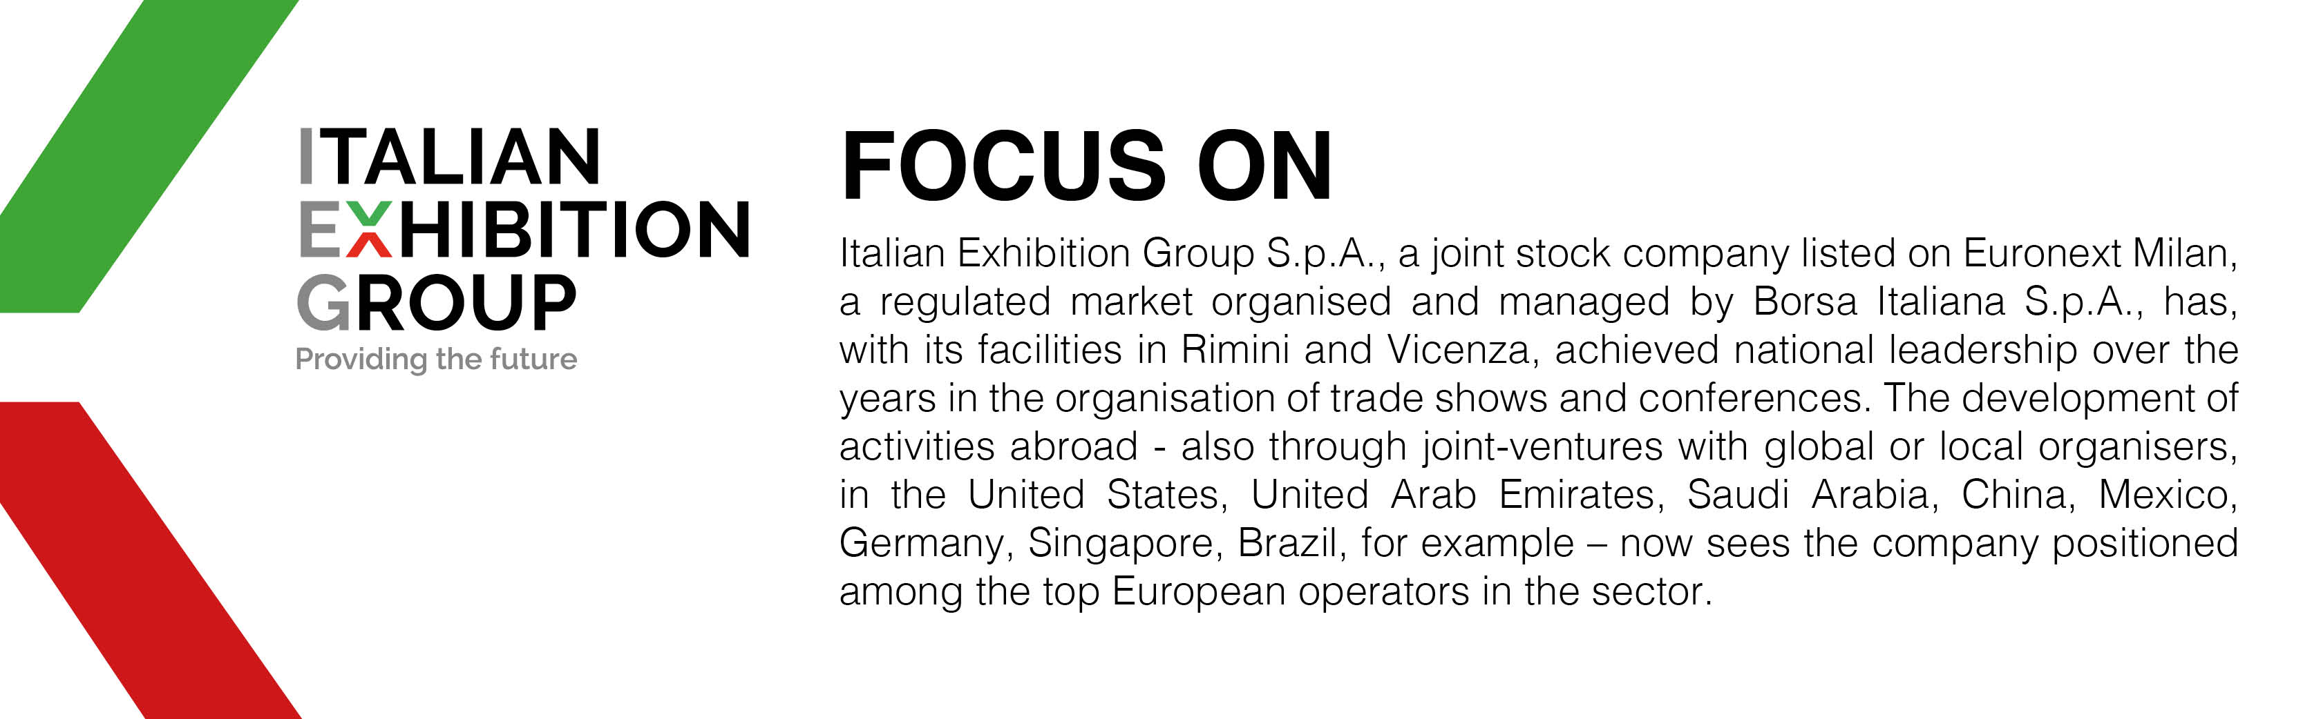

This press release contains forecast elements and estimates that reflect the management’s current opinions (“forward-looking statements”), particularly regarding future management performance, realization of investments, cash flow trends and the evolution of the financial structure. For their very nature, forward-looking statements have a component of risk and uncertainty, as they depend on the occurrence of future events. The effective results may differ (even significantly) from those announced, due to numerous factors, including, only by way of example: food service market and tourist flow trends in Italy, gold and jewellery market trends, green economy market trends; the evolution of raw material prices; general macroeconomic conditions; geopolitical factors and evolutions in the legislative framework. Moreover, the information contained in this release does not claim to be complete, and has not been verified by independent third parties. Forecasts, estimates and objectives contained herein are based on the information available to the Company as at the date of this release.

